Available data:

* Mixed model, distributions of the following parameters for 1980-1984 cohorts + all years:
  + Tgi, Tig, Tai, Tia, Tga, Tag, Cgi, Cig, Cai, Cia, Cga, Cag;
  + E.g. distribution for the parameters for all years  
    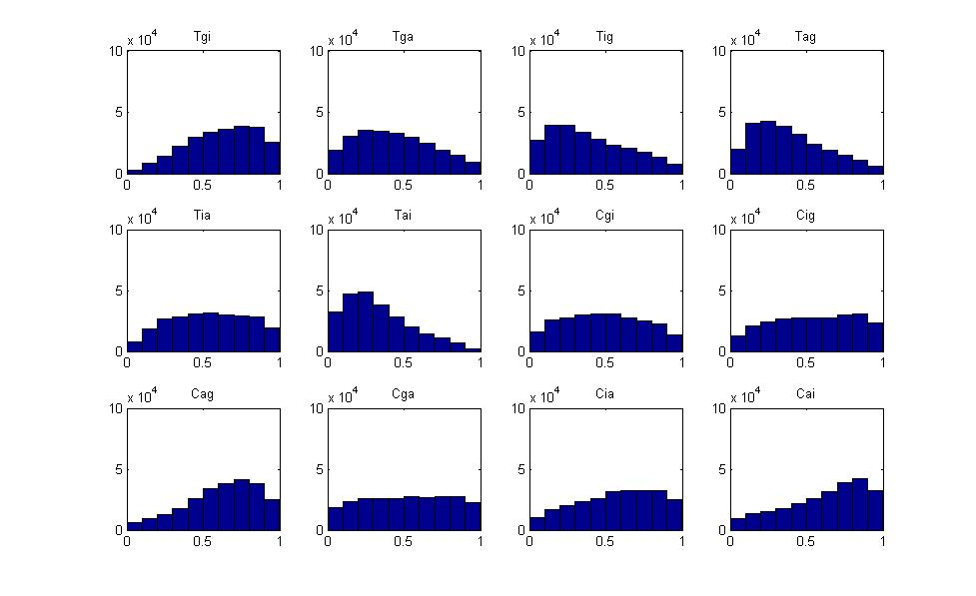
* Diffusion model, distributions of the following parameters for 1980-1984 cohorts + all years:
  + Kgi, Kig, Kai, Kia, Kga, Kag;  
    e.g. diffusion model parameters for 1984 cohort:  
    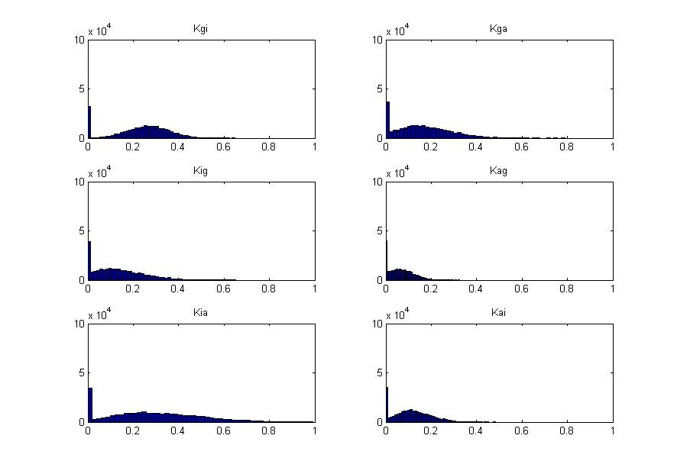
* Contagion model, distributions of the following parameters for 1980-1984 cohorts + all years:
  + Tgi, Tig, Tai, Tia, Tga, Tag;  
    e.g. contagion parameters for 1984 cohort  
    